Toy Store Sales Analysis

Project Overview:
This project presents an interactive Toy Store Sales Analytics Dashboard developed using Power BI to analyse sales performance, profitability, inventory, and product trends. The dashboard transforms raw retail sales data into meaningful business insights using Power Query for data transformation, DAX for business calculations, and Star Schema data modeling.
The project demonstrates the complete Business Intelligence workflow, enabling stakeholders to monitor key business metrics and make informed business decisions.

Business Problem:
Retail businesses often collect large volumes of transactional data but struggle to convert it into actionable insights.
This dashboard addresses the following challenges:
- Lack of centralized sales reporting
- Difficulty identifying top-performing products
- Limited visibility into store performance
- Poor understanding of monthly sales trends
- Difficulty monitoring profitability

Objectives:
- Analyse overall sales performance.
- Identify high-performing stores.
- Compare product category performance.
- Monitor monthly and yearly sales trends.
- Track inventory and profitability.
- Build an interactive dashboard for business decision-making.

Dataset Information:
Dataset | Description
Sales | Sales transactions
Products | Product information
Stores | Store information
Inventory | Inventory details
Calendar | Date dimension

Power Query (ETL):
ETL Process
- Imported multiple datasets.
- Cleaned missing values.
- Removed duplicate records.
- Changed data types.
- Renamed columns.
- Removed unnecessary columns.
- Loaded transformed tables into Power BI.

Data Model:
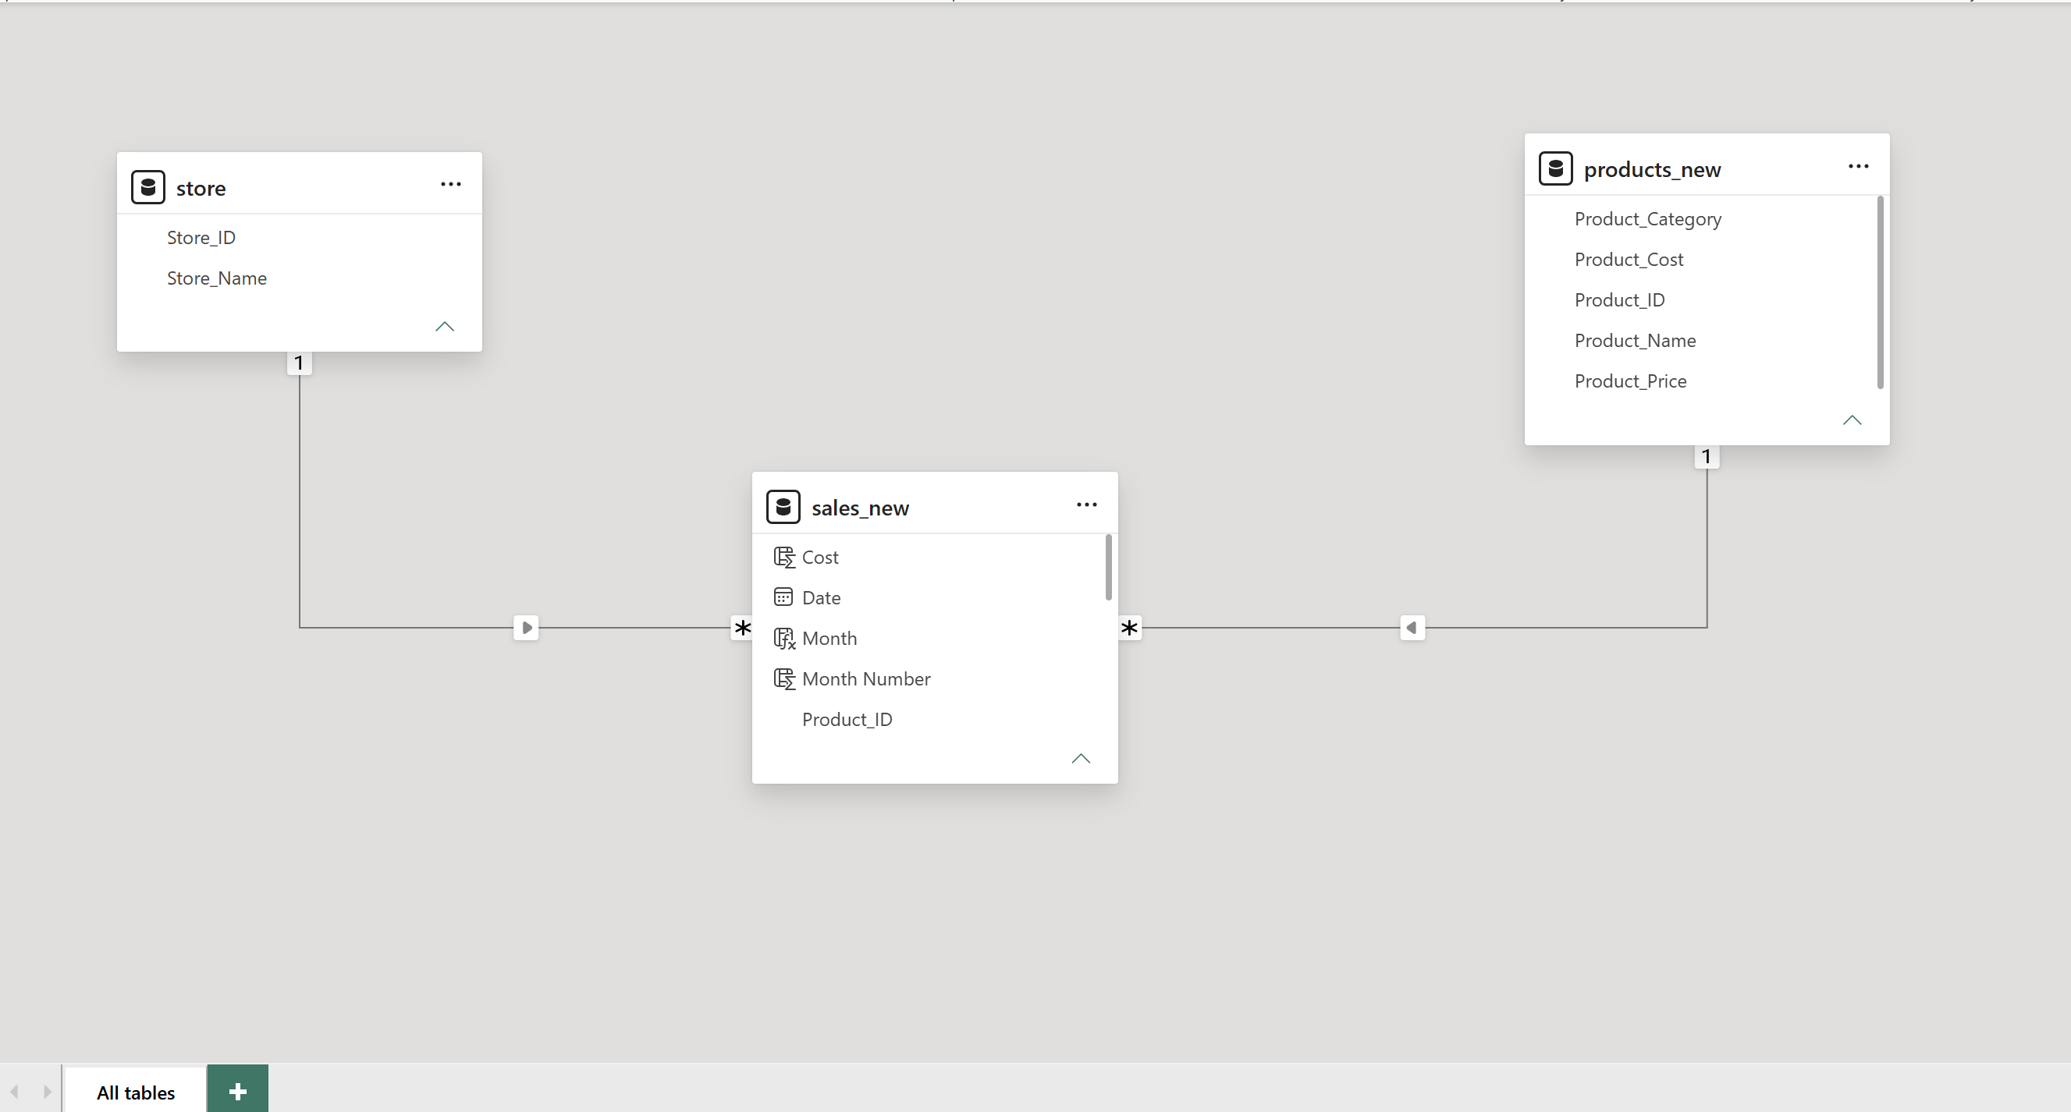
Data Modeling
A Star Schema was implemented by connecting fact and dimension tables through one-to-many relationships.
Benefits:
- Faster report performance
- Better DAX calculations
- Easy filtering
- Reduced redundancy

Key Business Insights:
- Store A generated the highest sales.
- Building Blocks category contributed the highest revenue.
- Peak sales occurred during the holiday season.
- Average Order Value remained consistent across stores.
- Some stores require inventory optimization due to lower sales.
Toy Store Sales Dashboard:
